SDD-630 Activity 5

Activity 5.1 Compare Application Development Tools

Background:
In this activity, you will create a comparison of the application languages and frameworks used in the context of mobile applications, paying close attention to advantages of each.

Instructions:
- Research current trends in the mobile application development world.
  - Search Google for comparisons such as "xamarin vs. react native vs. flutter vs. kotlin." You will likely discover additional tools and languages beyond these four titles.
  - Search for Google Trends, StackOverflow annual surveys, Indeed.com job statistics, GitHub usage reports, and Gartner reports. All of these resources provide measurable data that can help determine if a solution is mainstream, growing, or declining.
  - Limit the search results to the "Past Year" to get the most current information.
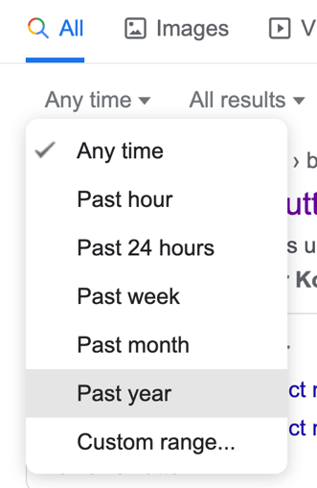
Figure 5.1 – Limit Google search results to the past year
  - Read blogs, articles, or Reddit threads to get a variety of viewpoints and opinions.

- Create a summary table of development languages and frameworks, describing the benefits of each. Use the template below.

The Current State of Application Development Tools
Name | Advantages | Disadvantages | Popularity | Age
Framework or Language | Why do people choose this solution? | Why do people avoid this? | How many people use this? Rising or falling? | How established is this?

Activity 5.2 Recommend a Development Solution

Instructions:
- Write a 1,000-word or longer recommendation for which languages or frameworks or other tools make the best business case for your mobile application begun in the previous activities.
- Provide a rationale for the choice you make that addresses the following questions:
  - Is a cross-platform solution better than creating native solutions? Cross-platform is supposed to save money without sacrificing quality. Be sure that both are true for your application before making a recommendation.
  - Are the latest tools "better"? According to some people, yes, but a business has to support a product for many years. This implies finding employees who know how to use the tools and applying security fixes when vulnerabilities are found.
  - A business may already have significant investment in a langue or framework. Sometimes it is better to follow the company's chosen language rather than choosing a "better," but incompatible solution.

Activity 5 Deliverables:

Activity 5.1 – Table of development tools, describing the benefits of each.
Activity 5.2 – 1,000-word document recommendation for which languages or frameworks you will use to develop the application.

